|  |
| --- |
|  |
| STOCK MARKET ANALYSIS  Assignment 4 |
| |  |  |  | | --- | --- | --- | | Paluri naga sai ushasree | 3/31/24 | DR LANKAPALLI BULLAYA COLLAGE,BBA | |

STOCK MARKET ANALYSIS

# CONTENTS IN THIS DOCUMENT INCLUDE

In this document, we are going to learn about **Voltas Company LTD.** Analyzing the performance using historical cost, calculating key metrics, and volatility, This document aims to present a thorough analysis of the performance of Voltas Company LTD. The analysis will be based on historical costs, key metrics, volatility, and average trading volume. Our objective is to provide a comprehensive report that can inform decision-making and contribute to the overall knowledge and understanding of the company's financial health. and average trading volume

1. **Company Overview**
2. **Historic data**
3. **Calculating key metrics**
4. **Comparing performance to relative index**
5. **Analysing significant events and news**
6. **COMPANY OVERVIEW**

Introduction to the company

voltas

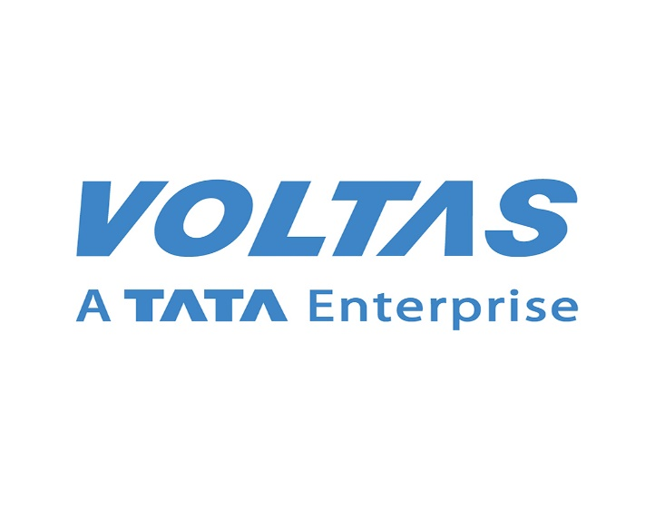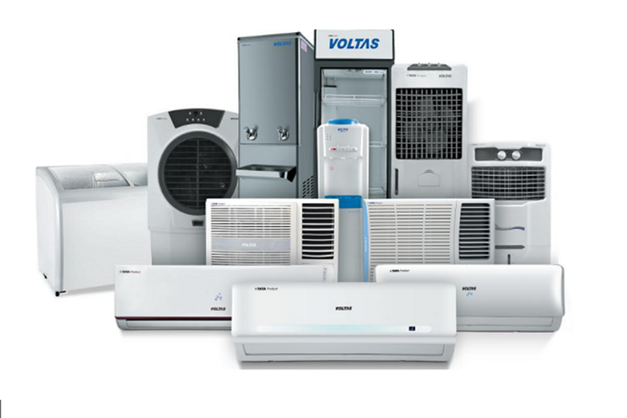

Voltas Limited is an Indian multinational home appliances company headquartered in Mumbai. It designs, develops, manufactures, and sells products including air conditioners, air coolers, refrigerators, washing machines, dishwashers, microwaves, air purifiers, and water dispensers. Voltas is India's largest air conditioning company by market share.

The company was incorporated on 6 September 1954 in Mumbai, as a collaboration between Tata Sons and Volkart Brothers. The company is currently chaired by Noel Tata and Pradeep Bakshi is the company's current chief executive officer and managing director. Voltas is a part of TATA ENTERPRISE

Company type: Public

Traded as

NSE: VOLTAS

BSE: 500575

Industry: Home appliances

# DATA ANALYSIS OF VOLTAS

**Voltas Financials**

ConsolidatedStandalone

| **QUARTERLY** | ANNUAL | **DEC 2023** | **SEP 2023** | **JUN 2023** | **MAR 2023** | **DEC 2022** |
| --- | --- | --- | --- | --- | --- |
| Total Income | 2,683.61 | 2,363.73 | 3,429.83 | 3,003.46 | 2,036.27 |
| Total Income Growth (%) | 13.53 | -31.08 | 14.20 | 47.50 | 11.11 |
| Total Expenses | 2,610.14 | 2,234.16 | 3,185.77 | 2,749.01 | 2,077.68 |
| Total Expenses Growth (%) | 16.83 | -29.87 | 15.89 | 32.31 | 16.48 |
| EBIT | 73.47 | 129.57 | 244.06 | 254.45 | -41.41 |
| EBIT Growth (%) | -43.30 | -46.91 | -4.08 | - | -184.36 |
| Profit after Tax (PAT) | -30.41 | 36.68 | 129.29 | 143.92 | -110.38 |
| PAT Growth (%) | -182.91 | -71.63 | -10.17 | - | - |
| EBIT Margin (%) | 2.74 | 5.48 | 7.12 | 8.47 | -2.03 |
| Net Profit Margin (%) | -1.13 | 1.55 | 3.77 | 4.79 | -5.42 |
| Basic EPS (₹) | -0.92 | 1.11 | 3.91 | 4.35 | -3.34 |

* **INCOME (P&L)**
* **BALANCE SHEET**
* **CASH FLOW**
* **RATIOS**
* **INSIGHTS**
  + **PAT: Slipping to Red**

The company posted a loss of Rs 30.41 cr on 31 Dec 2023 quarter after 3 consecutive quarters of profits. (Source: Consolidated Financials)

* + **Employee & Interest Expense**

The company has spent less than 1% of its operating revenues towards interest expenses and 7.02% towards employee costs in the year ending 31 Mar 2023. (Source: Consolidated Financials)

**BALANCE SHEET OF VOLTAS**

| **ANNUAL** | **FY 2023** | **FY 2022** | **FY 2021** | **FY 2020** | **FY 2019** |
| --- | --- | --- | --- | --- | --- |
| Total Assets | 10,279.01 | 9,746.33 | 8,655.48 | 8,156.06 | 7,521.98 |
| Total Assets Growth (%) | 5.47 | 12.60 | 6.12 | 8.43 | 2.90 |
| Total Liabilities | 4,785.29 | 4,208.69 | 3,626.03 | 3,839.36 | 3,377.24 |
| Total Liabilities Growth (%) | 13.70 | 16.07 | -5.56 | 13.68 | 0.13 |
| Total Equity | 5,493.72 | 5,537.64 | 5,029.45 | 4,316.70 | 4,144.74 |
| Total Equity Growth (%) | -0.79 | 10.10 | 16.51 | 4.15 | 5.28 |
| Current Ratio (x) | 1.40 | 1.45 | 1.48 | 1.49 | 1.72 |
| Total Debt to Equity (x) | 0.11 | 0.06 | 0.05 | 0.05 | 0.08 |
| Contingent Liabilities | 782.02 | 705.14 | 691.83 | 2,766.08 | 2,333.09 |

* *All figures in Rs Cr, unless mentioned otherwise*

**CASH FLOWS OF VOLTAS**

| **ANNUAL** | **FY 2023** | **FY 2022** | **FY 2021** | **FY 2020** | **FY 2019** |
| --- | --- | --- | --- | --- | --- |
| Net Cash Flow from Operating Activities | 159.38 | 584.23 | 556.11 | 462.45 | -321.43 |
| Net Cash Used in Investing Activities | -81.60 | -364.63 | -255.91 | -210.49 | 392.73 |
| Net Cash Flow from Financing Activities | 55.05 | -107.04 | -121.51 | -293.66 | -18.25 |
| Net Cash Flow | 132.83 | 112.56 | 178.69 | -41.70 | 53.05 |
| Closing Cash & Cash Equivalent | 693.36 | 560.53 | 447.97 | 269.28 | 310.98 |
| Closing Cash & Cash Equivalent Growth (%) | 23.70 | 25.13 | 66.36 | -13.41 | 20.57 |
| Total Debt/ CFO (x) | 3.86 | 0.59 | 0.45 | 0.47 | -0.98 |

*All figures in Rs Cr, unless mentioned otherwise*

**RATIOS OF VOLTAS**

| **ANNUAL** | **FY 2023** | **FY 2022** | **FY 2021** | **FY 2020** | **FY 2019** |
| --- | --- | --- | --- | --- | --- |
| Return on Equity (%) | 2.47 | 9.16 | 10.51 | 12.08 | 12.35 |
| Return on Capital Employed (%) | 12.38 | 14.64 | 15.45 | 20.00 | 18.26 |
| Return on Assets (%) | 1.31 | 5.17 | 6.06 | 6.34 | 6.75 |
| Interest Coverage Ratio (x) | 25.04 | 33.66 | 31.75 | 41.96 | 23.47 |
| Asset Turnover Ratio (x) | 0.78 | 0.79 | 0.79 | 93.89 | 94.71 |
| Price to Earnings (x) | 204.08 | 81.97 | 63.29 | 30.67 | 41.15 |
| Price to Book (x) | 4.96 | 7.49 | 6.64 | 3.70 | 5.07 |
| EV/EBITDA (x) | 36.47 | 47.06 | 39.71 | 17.21 | 26.17 |
| EBITDA Margin (%) | 7.79 | 10.97 | 10.98 | 11.97 | 11.20 |

[**Market Summary**](https://www.google.com/finance?rlz=1C1GCEA_enIN1097IN1098&oq=VOLTAS+STOCK+MARKET+ANALYSIS&gs_lcrp=EgZjaHJvbWUyBggAEEUYOdIBCjE0ODEwajBqMTWoAgiwAgE&sourceid=chrome&ie=UTF-8&sa=X&ved=2ahUKEwjFt8X-vqiFAxXT1zgGHelqCcwQ6M8CegQIOxAI)**> Voltas Ltd**

1,217.00 INR+398.85 (48.75%)past year

4 Apr, 3:30 pm IST

HISTORIC PRICE DATA

| Date | Price | Open | High | Low | Volume | Chg% |
| --- | --- | --- | --- | --- | --- | --- |
| Apr 2024 | 1,217.00 | 1,103.00 | 1,228.15 | 1,103.00 | 1.80M | 10.28% |
| Mar 2024 | 1,103.55 | 1,116.80 | 1,139.60 | 1,023.95 | 24.80M | -0.50% |
| Feb 2024 | 1,109.10 | 1,091.00 | 1,133.50 | 1,013.15 | 30.58M | 2.13% |
| Jan 2024 | 1,086.00 | 981.75 | 1,100.00 | 968.35 | 25.57M | 11.00% |
| Dec 2023 | 978.35 | 828.15 | 992.80 | 825.40 | 47.92M | 18.17% |
| Nov 2023 | 827.95 | 837.50 | 852.60 | 811.15 | 17.63M | -1.14% |
| Oct 2023 | 837.50 | 861.90 | 888.00 | 806.70 | 20.03M | -2.99% |
| Sep 2023 | 863.30 | 874.00 | 914.50 | 851.30 | 22.30M | -0.76% |
| Aug 2023 | 869.90 | 782.00 | 872.00 | 780.25 | 34.93M | 11.51% |
| Jul 2023 | 780.10 | 765.00 | 792.85 | 745.00 | 29.37M | 2.68% |
| Jun 2023 | 759.75 | 820.05 | 831.95 | 747.60 | 30.00M | -7.50% |
| May 2023 | 821.35 | 795.95 | 831.00 | 785.85 | 20.72M | 2.79% |
| Apr 2023 | 799.05 | 823.45 | 869.90 | 762.75 | 25.89M | -2.35% |
| Mar 2023 | 818.25 | 898.95 | 934.00 | 805.50 | 24.62M | -8.27% |
| Feb 2023 | 892.00 | 803.50 | 927.40 | 784.00 | 38.10M | 11.13% |
| Jan 2023 | 802.65 | 799.90 | 834.00 | 737.20 | 22.31M | 0.35% |
| Dec 2022 | 799.85 | 822.20 | 862.40 | 770.00 | 19.30M | -2.40% |
| Nov 2022 | 819.50 | 880.60 | 928.00 | 803.60 | 32.86M | -6.47% |
| Oct 2022 | 876.20 | 909.00 | 936.00 | 857.35 | 18.05M | -3.34% |
| Sep 2022 | 906.45 | 992.00 | 999.90 | 868.00 | 28.82M | -9.46% |
| Aug 2022 | 1,001.20 | 1,009.95 | 1,051.30 | 958.45 | 25.63M | -0.35% |
| Jul 2022 | 1,004.75 | 949.80 | 1,064.95 | 932.50 | 23.99M | 3.33% |
| Jun 2022 | 972.40 | 1,008.60 | 1,058.95 | 933.60 | 20.15M | -4.48% |
| May 2022 | 1,018.05 | 1,250.00 | 1,266.60 | 922.55 | 37.84M | -19.30% |

**Summary**

**Highest**

1,266.60

**Lowest**

737.20

**Difference**

529.40

**Average**

915.18

**Chg. %**

-3.53

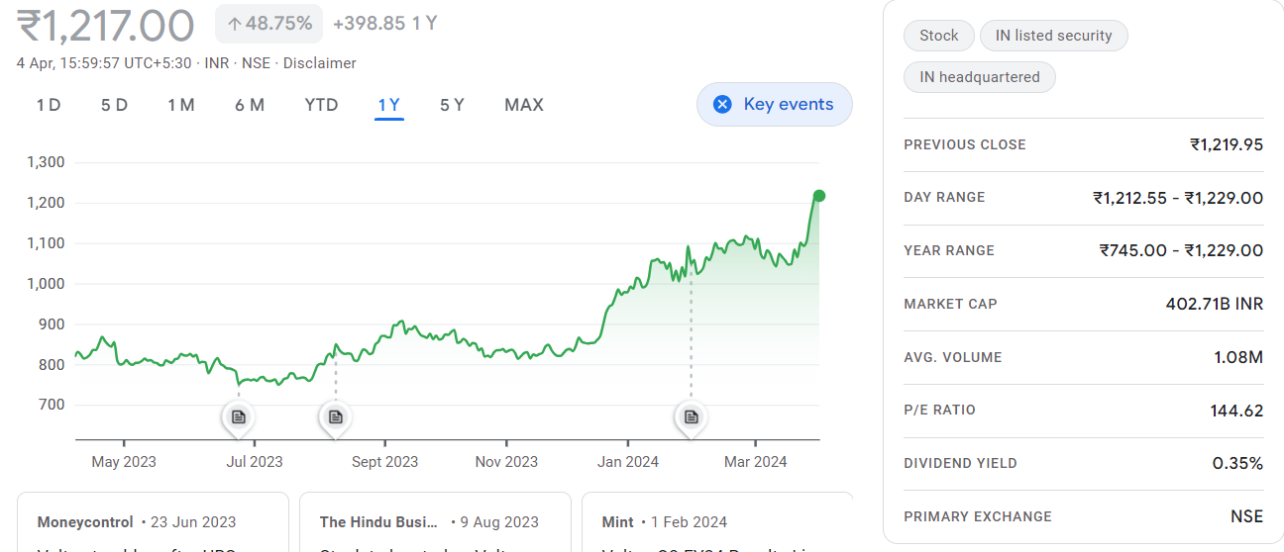

**Key Metrics**

**Key Metrics**

|  |  |
| --- | --- |
| PE Ratio  (x) | **144.20** |
| EPS - TTM  (₹) | **8.45** |
| MCap  (₹ Cr.) | **40,300.11** |
| Sectoral MCap Rank | **5** |
| PB Ratio  (x) | **7.35** |
| Div Yield  (%) | **0.35** |
| Face Value  (₹) | **1.00** |
| Beta | **0.97** |
| VWAP  (₹) | **1,220.29** |
| 52W H/L  (₹)  **1,229.00 / 745.00** |  |

Key metrics for assessing Volta's performance typically include financial indicators such as revenue growth, profitability margins, return on equity, and debt levels. Operational metrics such as market share, customer satisfaction, and employee productivity are also important factors to consider.

Here are some links that provide more information on key metrics for assessing Volta's performance:

1. Voltas Annual Reports: The company's annual reports provide detailed financial information and performance metrics. You can find the reports on Voltas' official website or financial news websites such as Moneycontrol or Bloomberg.

2. Stock Market Analysis Websites: Websites such as Yahoo Finance, Investing.com, and MarketWatch provide key financial metrics and performance indicators for Voltas and other publicly traded companies.

3. Industry Reports: Industry reports from research firms such as Frost & Sullivan or IDC may also include key metrics and benchmarks for assessing the performance of companies in the HVAC and cooling solutions industry, which Voltas operates.

4. Analyst Reports: Reports from equity research analysts at investment banks or brokerage firms often include key metrics and performance analysis for Voltas. These reports can be found on financial news websites or through your brokerage account.

It's important to consider a combination of financial, operational, and industry-specific metrics when assessing the performance of a company like Voltas. Conducting a thorough analysis of these metrics can help investors and stakeholders make informed decisions about the company's prospects and potential for growth.

**Volatility of voltas**

The volatility here is measured as the annualized standard deviation between monthly returns from the security over the past year. In most cases, the higher the volatility, the riskier the security.

Beta/Volatility of Voltas Ltd. (VOLTAS) on Daily/ Weekly/ Monthly Period

Beta Values of Voltas Ltd.

| **Period** | **Long Term Beta \*** | **Daily - One Month Range** | **Daily - Three Month Range** | **Weekly - One Year Range** | **Weekly - Two Year Range** | **2 Week - Two Year Range** | **Monthly - Two Year Range** |
| --- | --- | --- | --- | --- | --- | --- | --- |
| **VOLTAS Beta** | 1.03 | 1.07 | 0.990 | 0.207 | 0.790 | 0.965 | 0.620 |
| Mean | 945.15 | 1096.32 | 1073.24 | 897.94 | 912.71 | 911.43 | 910.09 |
| Standard Deviation | 8.04 | 2.00 | 2.15 | 3.26 | 3.91 | 6.09 | 7.65 |
| [VOLTAS Beta](https://www.topstockresearch.com/rt/Stock/VOLTAS/BetaAndVolatility) | 1.03 | 1.07 | 0.990 | 0.207 | 0.790 | 0.965 | 0.620 |
| [The beta of Blue Chip Stocks](https://www.topstockresearch.com/rt/IndexAnalyser/IndexAnalyser/NIFTY50/Overview/Beta)      [Learn Stock Beta](https://tutorials.topstockresearch.com/Beta/StockBetaExplained.html)      *Long Term Beta - Calculated on Mthly Tick over 4 Yr, updated daily, with the base as NIFTY50 | | | | | | | |

**AVERAGE TRADING VOLUME OF VOLTAS**

Voltas's average daily trading volume over the past year is 48.20%. The 3-month average is 23.61%, the 6-month average is 39.81%, and the 1-week average is 10.79%

As of April 4, 2024, Voltas's share price is up 0.13%, and the 52-week high is Rs 1,229.9, while the 52-week low is Rs 745.0. The stock has a price-to-earnings ratio of 144.56, an EPS value of 8.45, and a price-to-book value of 4.96.

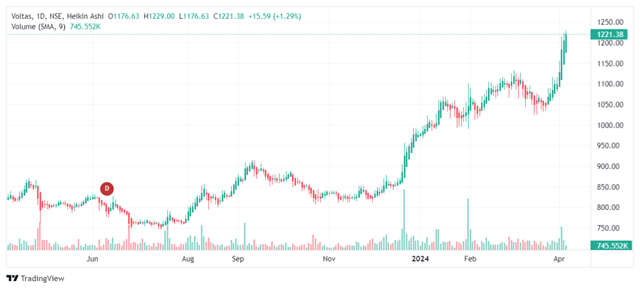

**COMPARING PERFORMANCE TO RELATIVE INDES**

|  |  |
| --- | --- |
| VLTSA.ltd | NDIA.AX |
| voltas | Global X India Nifty 50 ETF |
| Euronext FR | ASX |
| 7.330 | 73.490 |
| 7.520 | 73.490 |
| 7.170 | 72.500 |
| 7.520 | 72.570 |
| +0.140 | -0.730 |
| +1.90% | -1.00% |
| 164,141 | 14,880 |
| 221,198 | 13,428 |
| 7.380 | 73.300 |
| N/A | N/A |
| No | No |
| 6.530 | 72.643 |
| 98.82% | 38.94% |
| 55.79% | 51.27% |
| -44.45 | +20.77 |
| 56% Sell | 88% Buy |
| 56% Sell | 100% Buy |
| 100% Sell | 100% Buy |
| +14.16% since 03/26/24 | +0.96% since 03/26/24 |
| 6.430 on 03/28/24 | 71.960 on 03/27/24 |
| 7.520 on 04/02/24 | 75.000 on 04/02/24 |
|  |  |

|  |  |  |  |
| --- | --- | --- | --- |
| **1-Month** |  | | |
| %Chg | +5.49% since 03/04/24 | -2.06% since 03/04/24 |
| Low | 5.820 on 03/15/24 | 71.020 on 03/14/24 |

|  |  |  |
| --- | --- | --- |
| High | 7.520 on 04/02/24 | 75.000 on 04/02/24 |
| **3-Month** |
| %Chg | -19.18% since 01/04/24 | +5.85% since 01/04/24 |
| Low | 5.820 on 03/15/24 | 68.780 on 01/10/24 |
| High | 9.430 on 01/08/24 | 75.000 on 04/02/24 |
| **6-Month** |
| %Chg | -18.39% since 10/04/23 | +8.39% since 10/04/23 |
| Low | 5.820 on 03/15/24 | 64.800 on 10/27/23 |
| High | 10.540 on 01/02/24 | 75.000 on 04/02/24 |
| **Key Statistics** |
| Market Capitalization, $K | 936,996 | N/A |
| Shares Outstanding, K | 130,917 | N/A |
| Annual Sales | 469,027,000 | 0 |
| Annual Net Income | -7,174,000 | 0 |
| Last Quarter Sales | N/A | N/A |
| Last Quarter Net Income | N/A | N/A |
| 60-Month Beta | N/A | N/A |
| **Per-Share Information** |
| Most Recent Earnings | N/A | N/A |
| Latest Earnings Date | N/A | N/A |
| Most Recent Dividend | N/A | N/A |
| Next Ex-Dividends Date | N/A | N/A |
| **Ratios** |
| Price/Earnings ttm | N/A | N/A |

**SIGNIFICANTS EVENT OF VOLTAS**

Voltas Ltd. is an Indian multinational company specializing in air conditioning and cooling technology, as well as engineering solutions. Here are some key events in Voltas Ltd.'s history along with their effects on the company's present performance:

1. **Establishment** **in** **1954**: Voltas was established as a collaboration between Tata Sons and Volkart Brothers. This laid the foundation for the company's entry into the air conditioning and engineering sector in India.

2. **Diversification and Growth in the 1970s and 1980s**: During this period, Voltas diversified its product range into various engineering sectors including textile machinery, mining and construction equipment, and turnkey project execution. This diversification helped Voltas to establish itself as a prominent player in the engineering industry.

3. **Joint Venture with Carrier Corporation in 1983 Voltas** entered into a joint venture with Carrier Corporation, a global leader in heating, air conditioning, and refrigeration solutions. This collaboration helped Voltas to gain access to advanced technology and expand its product portfolio.

4**. Global Expansion in the 1990s:** Voltas expanded its footprint globally by establishing manufacturing facilities and offices in various countries. This global expansion helped Voltas to tap into new markets and strengthen its position as an international player in the HVAC (Heating, Ventilation, and Air Conditioning) industry.

5. **Focus on Sustainable Solutions in the 21st Century:** With growing awareness about environmental sustainability, Voltas shifted its focus towards providing energy-efficient and environmentally friendly solutions. This shift helped Voltas to meet the evolving demands of the market and enhance its brand image as a responsible corporate citizen.

6. **Strategic Acquisitions and Partnerships**: Voltas has strategically acquired companies and formed partnerships to strengthen its market presence and enhance its product offerings. For example, its acquisition of Rohini Industrial Electricals Ltd. in 2019 helped Voltas to expand its presence in the electrical and automation segment.

7. **Digital Transformation Initiatives: In recent years**, Voltas has invested in digital transformation initiatives to enhance its operational efficiency, improve customer experience, and stay competitive in the rapidly evolving market landscape. These initiatives include the adoption of digital technologies such as IoT (Internet of Things), AI (Artificial Intelligence), and data analytics.

Overall, these key events have contributed to Voltas Ltd.'s present performance by helping the company to establish a strong market presence, diversify its product portfolio, expand its global footprint, and adapt to changing market dynamics. Additionally, the company's focus on sustainability and digital transformation initiatives has further strengthened its position in the industry.

**Complete overview of voltas stock market**

Voltas is trading -0.23% lower at Rs 1,216.45 as compared to its last closing price. Voltas has been trading in the price range of 1,229.90 & 1,212.60. Voltas has given 24.69% in this year & 10.79% in the last 5 days.

Voltas has TTM P/E ratio 116.26 as compared to the sector P/E of 7.57.There are 34 analysts who have initiated coverage on Voltas. There are 5 analysts who have given it a strong buy rating & 8 analysts have given it a buy rating. 6 analysts have given the stock a sell rating.

The company posted a net profit of -30.41 Crores in its last quarter.

Listed peers of Voltas include [**Suzlon Energy**](https://www.livemint.com/market/market-stats/stocks-suzlon-energy-share-price-nse-bse-s0003098) (-1.06%), [**Thermax**](https://www.livemint.com/market/market-stats/stocks-thermax-share-price-nse-bse-s0003694) (1.49%), Voltas (-0.23%) etc.

Voltas has a 30.30% promoter holding & 69.70% public holding.The Mutual Fund holding in Voltas was at 16.98% in 31 Dec 2023. The MF holding has decreased from the last quarter. The FII holding in Voltas was at 17.18% in 31 Dec 2023. The FII holding has decreased from the last quarter.

... Read More

**1,217.95 -2.00 (-0.16%)**Updated : Thu 4 Apr, 2024 | 15:44:41

Advanced Chart

**Voltas share price range**

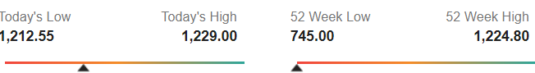

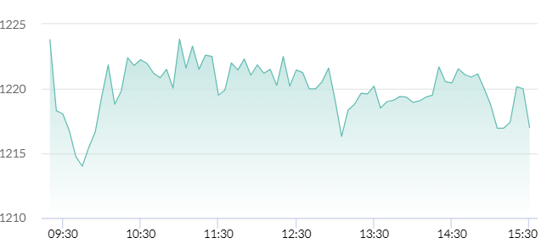

|  |  |  |  |  |  |
| --- | --- | --- | --- | --- | --- |
| |  | | --- | | Today's Low | | **1,212.55** | | |  | | --- | | Today's High | | **1,229.00** | |
|  | |
| |  | | --- | | 52 Week Low | | **745.00** | | |  | | --- | | 52 Week High | | **1,224.80** | |
|  | |

**Voltas share Key Metrics**

|  |  |
| --- | --- |
| Market Cap ( ₹ Cr.) | 40,366.28 |
| |  |  | | --- | --- | | Beta | 0.81 | | Div. Yield (%) | 0.35 | | P/B | 7.40 | | D/E | - | | Open Price | 1,226.00 | | |  |  | | --- | --- | | TTM P/E | 116.26 | | Peg. Ratio | 0.87 | | Sector P/E | 7.57 | | Prev. Close | 1,219.95 | |

[**VOLTAS share Key metrics**](https://www.livemint.com/voltas/key-metrics/companyid-s0003107)

**Voltas stock Analysis**

**Price Analysis**

|  |  |
| --- | --- |
| 1 Week | 10.79% |
| 3 Months | 23.61% |
| 6 Month | 39.81% |
| YTD | 24.69% |
| 1 Year | 48.20% |

**Risk Meter**

* 28%Balanced risk
* 

**Recos**

* Strong Sell
* Sell
* Hold
* Buy
* Strong Buy

**Analysts' Views**

|  |  |  |  |  |
| --- | --- | --- | --- | --- |
| **Ratings** | **Current** | **1 W Ago** | **1 M Ago** | **3 M Ago** |
| Strong Buy | 5 | 5 | 5 | 7 |
| Buy | 8 | 8 | 8 | 8 |
| Hold | 12 | 12 | 11 | 11 |
| Sell | 6 | 6 | 7 | 6 |
| Strong Sell | 3 | 3 | 3 | 2 |
| Total | 34 | 34 | 34 | 34 |

**Technical Trends**

**Long Term**

LM Info



**Bullish**

**Short Term**

LM Info



**Bullish**

* Bearish
* Moderately Bearish
* Neutral
* Moderately Bullish
* Bullish

**Note:** The stock is in strong bullish trend and investors should continue to hold.

**\*\*\*\*\***

**BY**

**PALURI NAGA SAI USHASREE,BBA,DR.L.B.C**

**ANDHRA UNIVERSITY**